**Project Management**

Assessment Two

Full Name: Yesid Giron Giron Student ID: 70403

Wells international college

|  |  |  |  |
| --- | --- | --- | --- |
| Name of Student | YESID ALBERTO GIRON GIRON | ID | 70403 |

**Assessment 2 – Research (Online)**

Contents

Instructions: 1

Duration: 2

Multiple-choice Questions: 2

Learning Notes: 7

What is project? 8

Please put your learning notes here: 8

Project management basic 8

Project management History 8

Project management in the future 9

Project Team 10

Document Search Index 10

## Instructions:

This is an individual assessment. Answer all the questions on the document provided by your Trainer.

## Duration:

Trainer will set the duration of the assessment.

## Multiple-choice Questions:

|  |  |
| --- | --- |
| 1. **What advice do we give about factoring in the commitments of project stakeholders when making your own plans?**     1. Consult student timetables to see when they might be free to attend data collection sessions.    2. Ask external organizations what the most convenient times would be for you to visit    3. Neither of these   d) Both A and B |  |

**Comment:** According to the PMBOK Guide, “A project charter is a document issued by the project initiator or sponsor that formally authorizes the existence of a project and provides the project manager with authority to apply organizational resources to project activities.”.

Web ref: <https://sustainet.com/managing-stakeholder-commitments/>

1. **Which of the following are essential components of a GANTT chart used to plan your project?** 
   1. Your home telephone number
   2. Your supervisor’s home telephone number
   3. The email address for the chair of the ethics committee
   4. None of the above

|  |  |
| --- | --- |
| Gantt charts are made up of nine components.   1. Dates. 2. Tasks. 3. Bars. 4. Milestones. 5. Arrows. 6. Taskbars. 7. Vertical Line Marker. 8. Task ID. 9. Resources. |  |

Web ref: [The 9 Essential Things In Your Gantt Chart (liveabout.com)](https://www.liveabout.com/gantt-chart-components-2779538)

1. **The intended outcome of strategy/projects integration is**

|  |  |
| --- | --- |
| * 1. Clear organization focus   2. Best use of scarce organization resources   3. Improved communication across projects and departments   4. Both A and C are correct   5. A, B, and C are all correct |  |

**Comment:** Integration management is a collection of processes required to ensure that the various elements of the projects are properly coordinated. It involves making trade-offs among competing objectives and alternatives to meet or exceed stakeholder needs and expectations.

Web Refer: <https://en.m.wikibooks.org/wiki/Project_Management/PMBOK/Integration_Management>

1. **Which of the following questions does the organization's mission statement answer?**

|  |  |
| --- | --- |
| * 1. What are our long-term strategies?   2. What are our long-term goals and objectives?   3. How do we operate in the existing environment?   4. What do we want to become?   5. All of these are answered by the mission statement |  |

**Comment:** A mission statement answers the question “What impact will you have on the world?” It’s your core purpose, your reason for being. Advance **Microsoft:** we work to help people and businesses throughout the world realize their full potential. This is our mission. Everything we do reflects this mission and the values that make it possible.

Web Refer: [Answer 4 Questions to Get a Great Mission Statement (forbes.com)](https://www.forbes.com/sites/patrickhull/2013/01/10/answer-4-questions-to-get-a-great-mission-statement/?sh=70234ba967f5)

1. **Which of the following is not one of the requirements for successful implementation of strategies through projects?**

|  |  |
| --- | --- |
| * 1. Allocation of resources   2. Prioritizing of projects   3. Motivation of project contributors   4. Adequate planning and control systems   5. All of these are requirements |  |

Strategy Implementation is the process used to make your strategic plan work. Whether you’re executing a new marketing plan to increase sales or introducing a new work management software to increase efficiency—your plan is only as valuable as the implementation.

Web Refer: <https://asana.com/resources/strategy-implementation>

1. **Which of the following is the reason(s) why project managers need to understand their organization's mission and strategy?**

|  |  |
| --- | --- |
| * 1. To make appropriate decisions and adjustments   2. To be effective project advocates   3. To be able to get their job done   4. Both A and B are correct   5. A, B, and C are all correct |  |

Understanding the organization`s mission and strategy is essential for project managers to ensure that their projects contribute to the organization`s success. They help us make decisions, allocate resources and manage risks.

Web Refer: [Why Project Managers Need To Understand Strategy - SSi People](https://www.ssipeople.com/why-project-managers-need-to-understand-strategy/)

1. **Which of these is the highest priority and first strategy required for any organizational change?**

|  |  |
| --- | --- |
| a) Communication   * 1. Stress management   2. Negotiation   3. Learning   4. Employee involvement |  |

**Comment:** There are three main ways in which leaders too often send confusing signals to their organisations. Leaders too often express what they want in terms of tasks, not outcomes, and rarely, if ever, clarify the full scope of the change they want. Second, leaders often fail to change the way they spend their own time. If leaders don't live and breathe change, people assume it can't be that important.

Third, leaders fail to allocate the right resources to support the change, and they fail to measure the change.

**Web reference:** [How to Communicate Clearly During Organizational Change (hbr.org)](https://hbr.org/2017/06/how-to-communicate-clearly-during-organizational-change)

1. **Which of the following is not a procedure to obtain an understanding risk in the planning stage (described in ISA 315):**

|  |  |
| --- | --- |
| * 1. Inquiries of management   2. Analytical procedures   3. Observation and inspection   4. Procedures for sampling audit tests |  |

**Comment:** Risk management is the process of identifying, assessing and controlling the financial, legal, strategic and security risks to the capital and earnings of an organisation. These threats, or risks, can arise from a variety of sources. These include financial uncertainty, legal liabilities, strategic management failures, accidents and natural disasters.

**Web reference**: [Going concern | ACCA Qualification | Students | ACCA Global](https://www.accaglobal.com/gb/en/student/exam-support-resources/professional-exams-study-resources/p7/technical-articles/going-concern.html)

1. **Assessment of control risk includes three steps. Which of the following is not one of these steps?**

|  |  |
| --- | --- |
| * 1. Obtaining an understanding of internal controls and documentation of the controls   2. Evaluate sufficiency and appropriateness of audit evidence   3. An initial assessment and response to assessed risk based on the design of internal controls resulting in an audit planning memorandum and audit plan   4. A final assessment based upon test of controls of operating effectiveness |  |

**Comment:** Control risk is the potential for a misstatement in a transaction, account balance or disclosure that could be material, either individually or in the aggregate with other misstatements, and that the internal control process does not detect, prevent or correct in a timely manner.

**Web reference**: [Identify, assess and control hazards - Managing risks | Safe Work Australia](https://www.safeworkaustralia.gov.au/safety-topic/managing-health-and-safety/identify-assess-and-control-hazards/managing-risks)

1. **Which of the following are not common internal control documentation techniques used by auditors?**

|  |  |
| --- | --- |
| a) Questionnaires   * 1. Company internal control manuals   2. Narrative descriptions   3. Check lists |  |

**Comment:** Documenting internal control procedures and processes can be challenging. The steps involved in producing good documentation include interviewing, observing, evaluating and organising the people involved. Presenting complex processes in an easy-to-understand style is no easy task.

**Web reference**: [How to Document Internal Controls and Processes | Bizfluent](https://bizfluent.com/how-6162124-document-internal-controls-processes.html)

1. **Overall response to assessed risk may include:**

|  |  |
| --- | --- |
| * 1. Identify the absence of key controls (where controls are lacking)   2. Identify existing controls   3. Incorporating additional elements of unpredictability in the selection of further audit procedures to be performed   4. Determine potential material misstatements that could result |  |

**Comment:** Audit procedures are a set of methods by which the auditor obtains audit evidence as part of the audit process. They are a part of the audit process and will vary depending on the nature of the client.

**Web reference**: [Auditing Standard No. 8 | PCAOB (pcaobus.org)](https://pcaobus.org/oversight/standards/archived-standards/pre-reorganized-auditing-standards-interpretations/details/auditing-standard-no-8_1838)

1. **Action plan Should be**

|  |  |
| --- | --- |
| 1. Specific 2. Countable 3. Realistic 4. Achievable   **Comment:** An action plan is a detailed plan outlining actions needed to reach one or more goals. Alternatively, businessdictionary.com defines an action plan as a "sequence of steps that must be taken, or activities that must be performed well, for a strategy to succeed".  Web Refer: <https://en.wikipedia.org/wiki/Action_plan> |  |

1. Which of the following is not a function of Project Management Tool?

|  |  |
| --- | --- |
| * 1. Plan a project   2. Manage Tasks   3. Manage Issues   4. Time Tracking   5. None of above |  |

**Comment:** Project management software brings teams together. It enables everyone in the organisation to prioritise the work that matters most. Use our guide to narrow the options and understand which tools are best for each business type.

**Web reference**: [The 11 Best Project Management Software & Tools [2023] • Asana](https://asana.com/resources/best-project-management-software)

1. **The project manager for the ERP Project, is about to complete the project phase review. The completion of a project phase is also known as which of the following?**

|  |  |
| --- | --- |
| a) A lesson learned   * 1. A kill point   2. Earned value management   3. Conditional advancement |  |

**Web reference**: [Pros and Cons of Using an ERP | NetSuite](https://www.netsuite.com/portal/resource/articles/erp/erp-pros-cons.shtml)

1. **Which of the following is not a key stakeholder in a project that creates a service internal to an organization?**

|  |  |
| --- | --- |
| * 1. The project manager   2. External customers   3. Project vendors   4. Project team members |  |

**Web reference**: [Who are Project Stakeholders and Why They are Important? (knowledgehut.com)](https://www.knowledgehut.com/blog/project-management/who-is-project-stakeholder#types-of-project-stakeholders-in-project-management)

1. **Managing a project is best described as which one of the following?**

|  |  |
| --- | --- |
| * 1. Establishing direction   2. Functional controls over the project team and stakeholders   3. Consistently producing key results expected by stakeholders   4. Motivating and inspiring the project team to produce results that are expected by project stakeholders |  |

**Comment:** Consistently delivering key results that meet stakeholder expectations is critical in project management. This involves the careful planning, organisation and control of the project's activities. It's about ensuring that project goals are aligned with stakeholder expectations, and that the project team is able to deliver these results effectively and efficiently.

**Web reference**: [Key Stakeholders: Definition, Benefits and How To Identify | Indeed.com](https://www.indeed.com/career-advice/career-development/key-stakeholders)

1. **You are the project manager for your organization. Influencing your organization requires which of the following?**

|  |  |
| --- | --- |
| * 1. An understanding of the organizational budget   2. Research and documentation of proven business cases   3. An understanding of formal and informal organizational structures   4. Positional power |  |

**Comment:** An informal organisation is the exact opposite of a formal organisation. This is not the case in an informal organisation. The main difference between the two is that in a formal organisation all members follow a chain of command.

**Web reference**: [10 Common Project Management Challenges And Their Solutions | Toggl Blog](https://toggl.com/blog/project-management-challenges)

1. **What is the difference between a standard and a regulation?**

|  |  |
| --- | --- |
| * 1. Standards are mandatory; regulations are not.   2. Standards are optional; regulations are not.   3. Regulations and standards are essentially the same.   4. Regulations are usually mandatory; standards may be seen as guidelines. |  |

**Comment:** Standards are generally established by consensus. They are made available to the public by standards organisations. Non-compliance with standards can lead to penalties or legal consequences. They serve as guidelines and are often voluntary, meaning that companies can choose whether or not to follow them.

**Web reference**: [Do you know the difference between standards and regulations? - Risk and Resilience Hub](https://www.riskandresiliencehub.com/do-you-know-the-difference-between-standards-and-regulations/)

1. **Which of the following is an example of a deliverable at the end of the requirements-gathering phase in a software design project?**

|  |  |
| --- | --- |
| * 1. Responsibility matrix creation   2. Detail design document   3. Business needs   4. Project team assembled |  |

**Comment:** This guide will show you what project management deliverables are, why they’re important to project management, and give you some tips for handling them in your own projects. A good project manager is able to identify the deliverables that need to be achieved on the way to project completion, and create a detailed project management plan to achieve them. With modern teams tackling a wide range of digital initiatives, it's more important than ever to define and deliver successful outcomes.

**Web reference**: [A Project Manager’s Guide to Project Deliverables | Upwork](https://www.upwork.com/resources/project-deliverables)

1. **At what point in a project would a kill point be acceptable?**

|  |  |
| --- | --- |
| * 1. When a project team member is not performing as planned   2. When a project reaches the end of a project phase   3. When a project reaches the end of its budget   4. When a project manager determines the project team cannot continue |  |

**Comment:** The other options (a, c and d) could potentially influence the decision at a kill point, but are not kill points themselves. A kill point, also known as a stage gate or phase gate, is a point in a project where its continuation is re-evaluated. It's usually an acceptable point when a project has reached the end of a project phase.

**Web reference**: [Kill Point In Project Management - Dee Project Manager](https://deeprojectmanager.com/kill-point-in-project-management/)

1. **Of the following, which is not an exit criterion?**

|  |  |
| --- | --- |
| * 1. Customer sign-offs   2. Quality metrics   3. Stakeholder analysis   4. Regulatory inspections |  |

**Comment:** Exit criteria assessment assesses the performance of your tests against the defined and agreed exit criteria. On the basis of this evaluation we can decide whether we have in fact performed enough testing for that level to mark it officially closed.

**Web reference**: [Defining Exit Criteria for All Stages of Your Agile Project - TestRail](https://www.testrail.com/blog/agile-exit-criteria/)

1. At which point is the risk of failure the least but the consequence of failure the highest?

|  |  |
| --- | --- |
| a) During the early stages   * 1. During the middle stages   2. During the final stages   3. Risk of failure is even across all project phases |  |

**Comment:** The risk of failure is usually lowest in the final stages of a project because most of the uncertainties have been resolved. However, the consequences of failure at this stage can be the highest because a lot of resources have already been invested and there may not be enough time or resources to correct the failure.

**Web reference**: [Project Failure Risk: Mitigation and Control Strategies (mentorworks.ca)](https://www.mentorworks.ca/blog/business-strategy/project-failure-risk-strategies/" \l ":~:text=The%20final%20stage%2C%20Closing%2C%20is%20the%20least%20risky%2C,do%20not%20present%20themselves%20until%20the%20very%20end.)

1. **In project estimation, project manager has to provide an expert judgement, which are considered of the following EXCEPT:**

|  |  |
| --- | --- |
| * 1. Impact of inflation over the project lifecycle   2. Required labour and labour rates   3. Material costs and assumptions   4. Costs of quality   5. All of above   6. None of above |  |

**Comment:** Expert judgment estimation method uses project manager and team's knowledge to accurately estimate resources and set reasonable deadlines. Effective when project manager has extensive project management experience. Relies on their expertise to determine project requirements.

**Web reference**: [How To Use Expert Judgment In Project Management [2023] • Asana](https://asana.com/resources/expert-judgment)

1. **Which component is/are included in Quality Management Plan** 
   1. 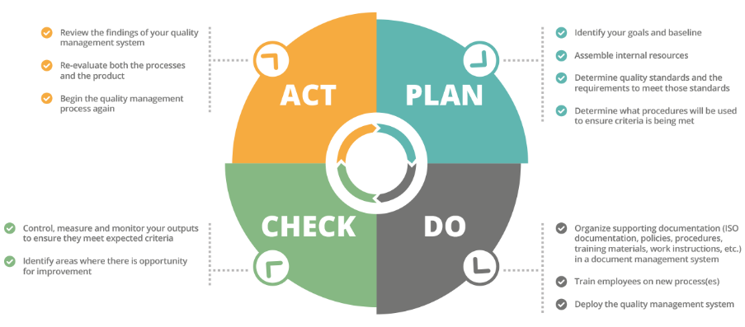Quality objectives
   2. Key project deliverables
   3. Quality standards
   4. Quality control and assurance activities
   5. All of above

**Comment:** The four main components of a quality management process are Quality Planning, Quality Assurance, Quality Control and Continuous Improvement.

In order to get the best outcome, we need good quality management process.

Web Refer: <https://info.docxellent.com/blog/main-components-quality-management>

Web Comment: When broken down, [quality control management](https://docxellent.com/document-control-solutions/quality-management/) can be segmented into four key components to be effective: quality planning, [quality control](https://docxellent.com/document-control-solutions/change-control/), [quality assurance](https://docxellent.com/service-support/software-quality-assurance/), and quality improvement.

1. **What's an activity sequencing** 
   1. The process for identifying and documenting dependencies among schedule activities
   2. The process for identifying critical activities
   3. The process for identifying ordering and schedule activities
   4. The process for planning the project

**Comment:** Activity sequencing is crucial in project management. It helps project managers determine the order in which activities should be performed to achieve project goals. By identifying activity relationships, project managers can develop a realistic project schedule, allocate resources effectively, and ensure timely and budgeted project completion.

Web Refer: [How to Sequence Activities in a Project - ProjectManager](https://www.projectmanager.com/blog/how-to-sequence-activities)

## Learning Notes:

<https://www.youtube.com/watch?v=rBSCvPYGnTc&t=1323s>

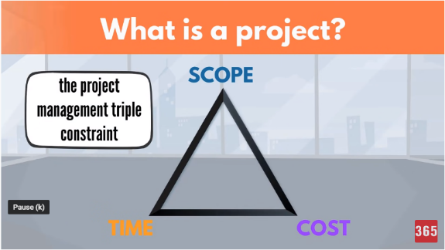A project is something extremely useful for people that want to accomplish their future ideas.

A project is a temporary endeavour undertaken to create a unique product, service or result.

Day to day activities have no end date.

Project on the other hand have a strict expiry date.

Project output is product or service or result.

Project shows different scope.

If the scope is not unique, this is a regular business process.

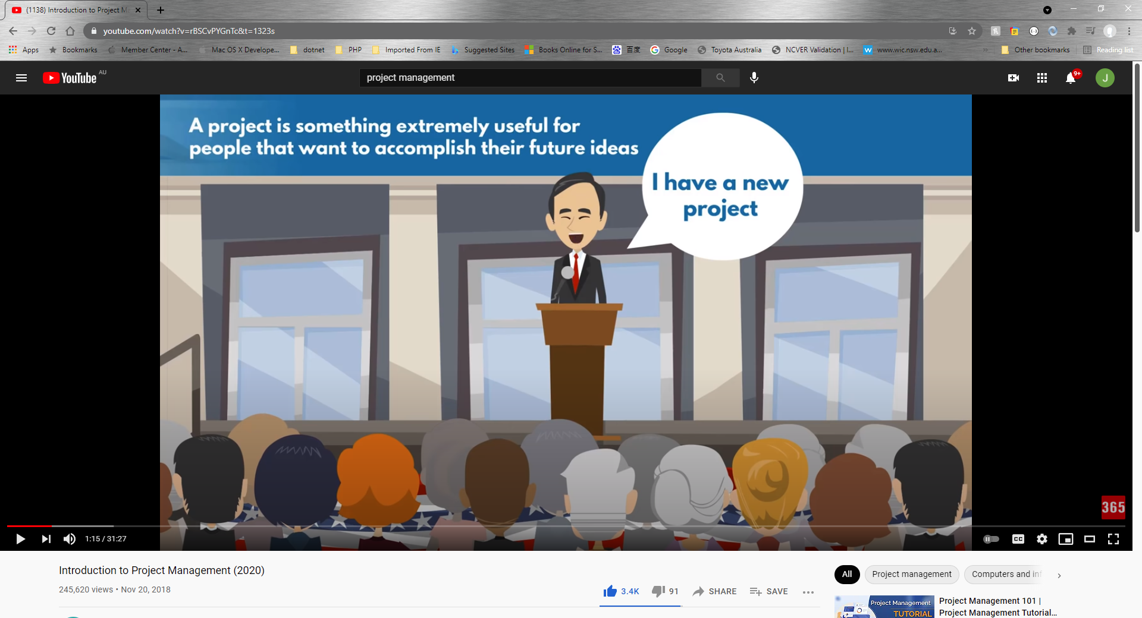

## What is project?

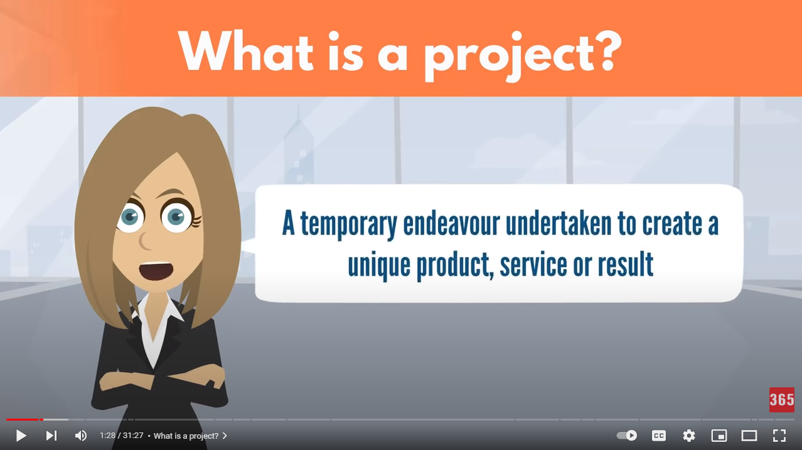

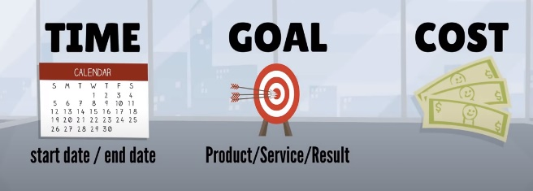project need you make a big effect in order to achieve a unique or specific goal…

project need show start date or time and finish date or time

## Please put your learning notes here:

## Project management basic

## Project management History

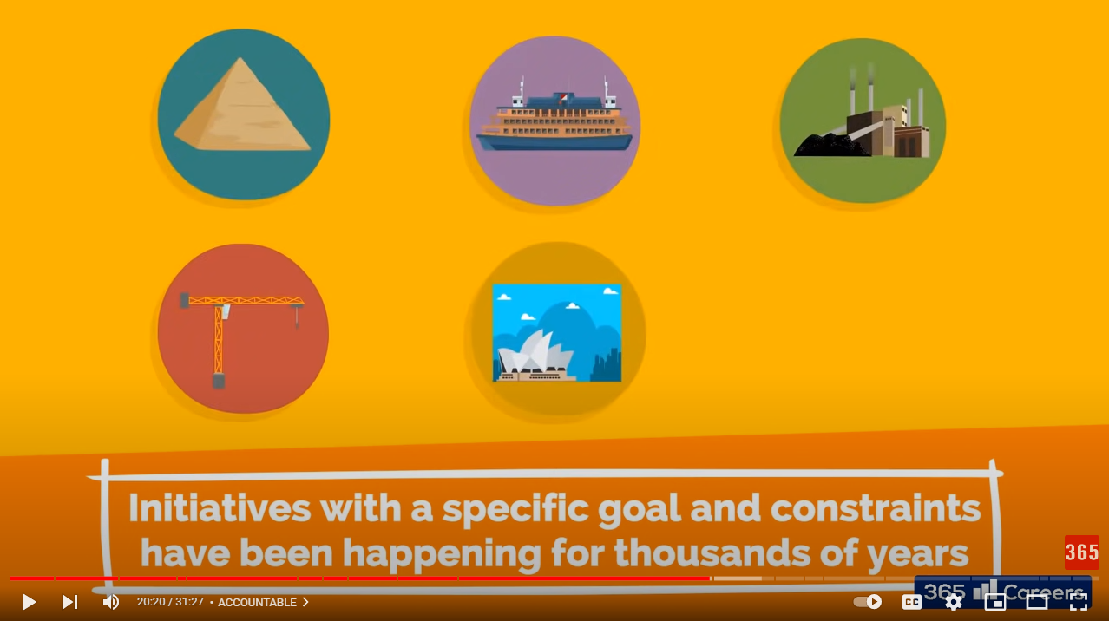

Good example is: Ancient Egypt build a big project!

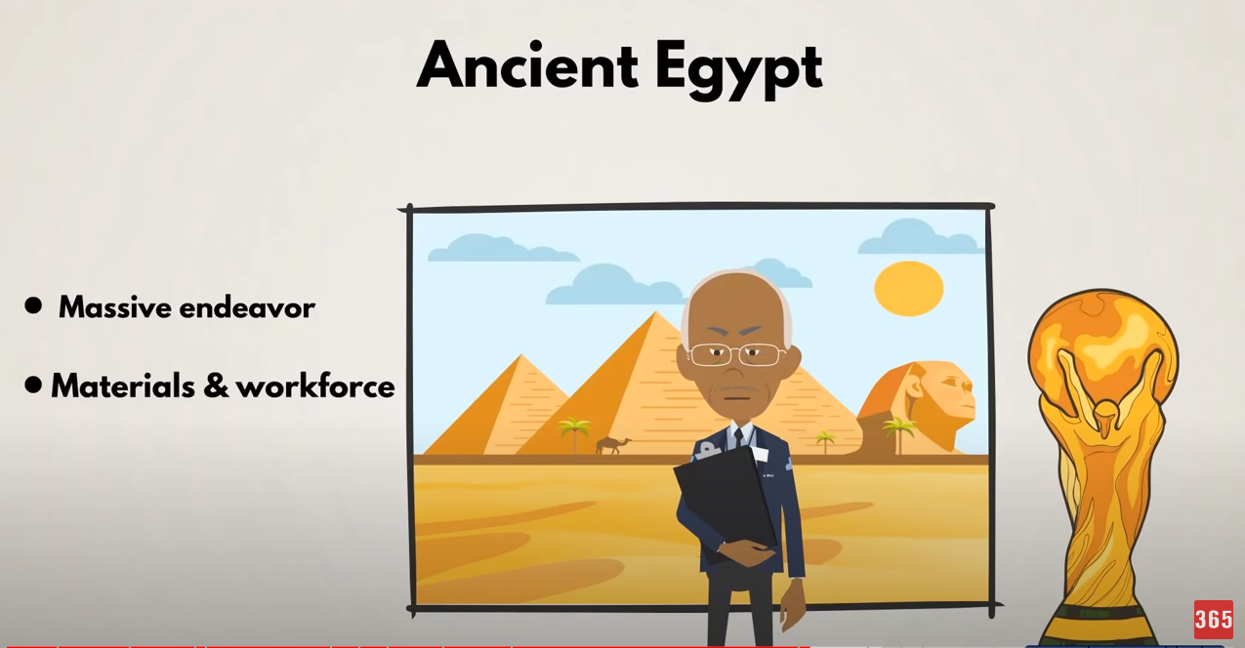

20 Century the Henry Gantt first make Gantt Chart Diagram. It is the revolution to know more about project management.

## Project management in the future

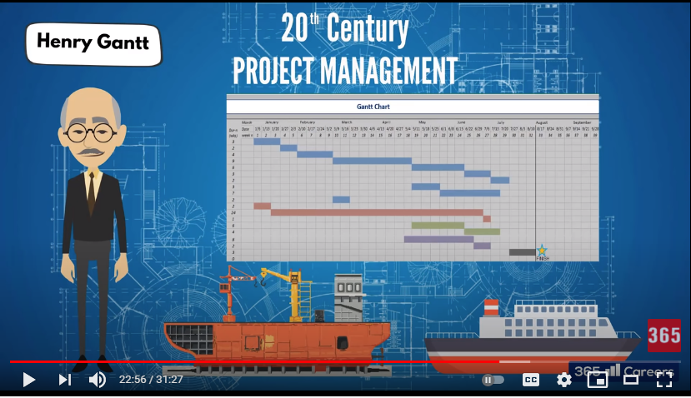

## Project Team

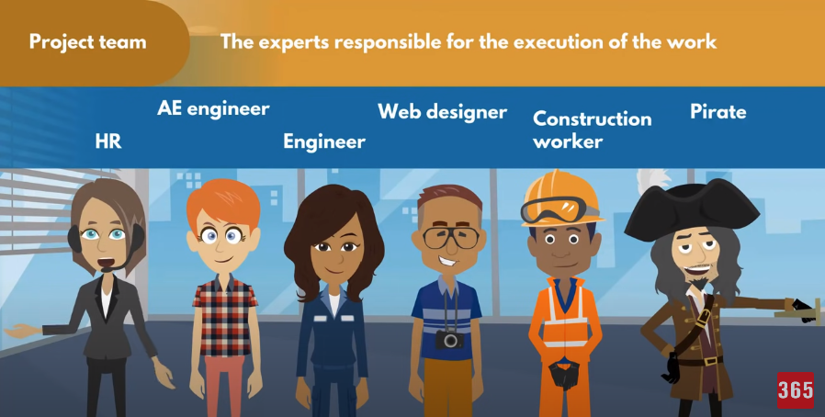

The experts responsible for the execution of the work

## Document Search Index

A

a GANTT chart 2

M

mission and strategy 3

mission statement 3

O

organizational change 3

P

project stakeholders 2

projects integration 2

S

successful implementation 3

U

understanding risk 4